

**Assess the different length of the model and spin-up time. How to avoid all artificial open boundary effects.**

In order to get a well wedge, we set left boundary discharge as 3000m3/s and right boundary as S2 tide so that flow ratio will be less than 0.1.

Actually, the mixing process is driven by pressure gradient and tide.

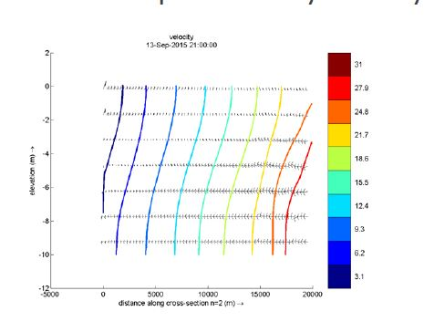

Parameters set in base case

|  |  |  |  |  |  |
| --- | --- | --- | --- | --- | --- |
|  | Hori. Viscosity | Hori. Diffusivity | Vert. viscosity | Vert. diffusivity | Ozmidov length scale |
| Value | 1 | 2.5 | 1e-4 | 1e-6 | 1e-8 |

|  |  |  |  |
| --- | --- | --- | --- |
|  | Grid size | TH time lag | Initial salinity |
| Fig.1 | x=100000 y=200 | 0/0 | 31 |
| Fig.2 | x=100000 y=200 | 0/360 | 31 |
| Fig.3 | x=100000 y=200 | 0/0 | 0 |
| Fig.4 | x=200000 y=200 | 0/0 | 31 |
| Fig.5 | x=400000 y=200 | 0/0 | 31 |

|  |  |
| --- | --- |
| (a) final time step | (b) water level changes with time |
| (c) salinity changes with time (first layer) | (d) salinity changes with time (10th layer) |

Fig.1

We could observe spin-up time for base case in the first layer is around 3 days while beyond 3 days in the 10th layer.

This issue arises from artificial open boundary effects because horizontal transport is advection dominated and only one boundary condition is needed to specify the concentration. Basically, if we set this TH value as 0, we assume boundary condition dominates while inertial condition dominates for higher TH value.

In terms of this, we introduce Thatcher Harleman Time Lag to compensate. We set TH value as 360 min which is 6 hours because that is half of tidal period.

|  |  |
| --- | --- |
| 1. Salinity along distance | (b) velocity changes with time |
| (b)water level changes with time | (d) salinity changes with time |

Fig,2

Spin-up time for this case is around 2 days according to salinity history plot but we don’t notice huge difference in the first layer because salinity is faster mixed due to higher velocity. Actually we could observe spin-up time better if plot bottom layer.

We vary initial condition to test spin up time. at the beginning, initial salinity is 31, salinity on the left boundary is 0 and 31 on the right boundary. Then, we set initial salinity as 0.

|  |  |
| --- | --- |
| (a) final time step | (b) water level |
| (d) salinity changes with time (1st layer) | (d) salinity changes with time (10th layer) |

Fig.3

Spin-up time in the first layer gets no big difference as well while in the 10th layer it is 4 days delay than base case. At the bottom, stabilized salinity is away from initial salinity. Thus, it takes longer time to remain stable.

To further assess the impact of different grid size, then we extend to 200km and 400km respectively.

|  |  |
| --- | --- |
| (a) final time step | (b) water level |
| (c) salinity changes with time (TH 0) | (d) salinity changes with time (TH 360) |

Fig.4

|  |  |
| --- | --- |
| (a) final time step | (b) water level |
| (c) salinity changes with time (TH 0) | (d) salinity changes with time (TH 360) |

Fig.5

We observe the spin-up time for larger grid becomes longer also. Because of the driving source, density gradient becomes smaller once we extend grids. Mixing process takes longer time and thus boundary condition experiences longer time to match initial condition.

In this, we can obviously notice the impact of TH value. It helps to alleviate tidal boundary issues (purple line is observation at right boundary) and shorten spin-up time.